CUT THE STAINLESS STEEL TRACK TO THE LENGTH REQUIRED (IF IT HAS NOT ALREADY BEEN CUT FOR YOU.) SECURE THE TRACK WITH SCREWS TO THE HEAD OF THE DOOR FRAME OR CLOSEST FIRM FIXING ABOVE.

TAKE A MEASUREMENT FROM THE TOP OF THE TRACK TO THE FLOOR. YOU MUST THEN SUBTRACT 75mm OR 3" FROM THIS MEASUREMENT. THIS IS THE CURTAIN LENGTH AND WILL ALLOW FOR CLEARANCE AT THE BOTTOM AND FOR FIXING THE PLATE AT THE TOP. LAY THE PVC CURTAIN ON A FLAT SURFACE AND CUT TO THE DESIRED LENGTH USING A STANLEY KNIFE. THIS MUST BE CUT SQUARE FOR THE CURTAIN TO HANG VERTICALLY.

IF USING STEEL PLATES THEN PLEASE SANDWISH THE PVC BETWEEN THE FRONT & BACK PLATES AND ATTACH TOGETHER WITH RIVETS.
IF USING POLYCARBONATE PLATES THEN PLACE THE PVC IN BETWEEN THE TWO FACES, “PATENT PENDING” LOGO TO THE FRONT, AND SCREW THE TWO FACES TOGETHER WITH SUPPLIED SCREWS.

THE STRIPS ARE NOW READY TO BE ATTACHED TO THE HANGING RAIL. *PLEASE SEE SEPERATE OVERLAP GUIDE TO ENSURE CORRECT INSTALLATION*

FOR SUPPLY ONLY READY-MADE ORDERS, PLEASE STATE THE SIZE FROM
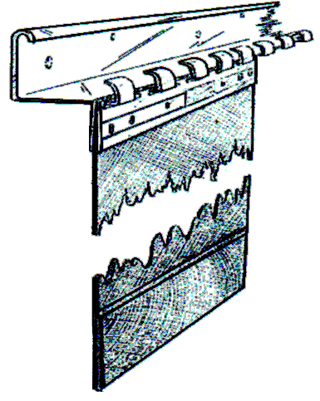 THE TOP OF THE TRACK TO THE BOTTOM OF THE CURTAIN. SEE FIG. 1

